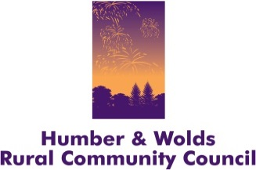
Draft Only

Contributing to and supporting the health and wellbeing of our organisations, communities and residents

&

Annual General Meeting

THURSDAY, 16 NOVEMBER 2017
The Ropewalk, Maltkiln Road, Barton upon Humber, North Lincolnshire, DN18 5JT

Notice is hereby given that the Annual General Meeting of Humber and Wolds Rural Community Council (HWRCC) will be held as above.

Please book your place by emailing: info@hwrcc.org.uk or telephoning 01652 637700

Agenda

1.30pm Arrival, registration and refreshments
An opportunity to meet HWRCC Trustees and staff, discuss your community issues and look at possible solutions. Take a look at current and new projects.
2.15pm Welcome

How HWRCC currently contributes to the health and well-being agenda in northern Lincolnshire:
- Voluntary Car Scheme (North Lincs)
- Wheels to Work
- Men in Sheds Winterton
- Winteringham Village Hall (Village SOS)
(Rather than us talking I suggest we video recipients of the service and play these back?)

Working in Partnership:
Community Transport Forums in North and North East Lincolnshire

Being part of the solution:
Use the flowchart I did for discharge lounge at HRI (see attached) or by then we may have some work activity with North/North East Lincs through the transport forum.

Questions

3.15pm Everyone is welcome to stay for the AGM
3.30pm Annual General Meeting
- Welcome and Introductions
- Apologies for absence
- Minutes from the AGM held on 16 November 2016 – new name and logo could be here as ‘rebranding’ is a matter arising (again!)
- Chairman’s Report
- Annual Review 2016/17 – (very short summary, refer to it only)
- Trustees Annual Report and Financial Accounts – adoption
- Appointment of Board of Directors (formalise DH, JW, BC, TC) Accountant/Treasurer, Trustee vacancies in general? For approval
- HWRCC going forward – new name and logo – the big reveal? (if not above?) for approval
- Appointment of Independent Examiners
- Arrangements for the Annual General Meeting 2018
- Question and Answer session

4.00pm Close of AGM

