Humber and Wolds Rural Community Council (HWRCC), trading under the name Humber and Wolds Rural Action (HWRA)
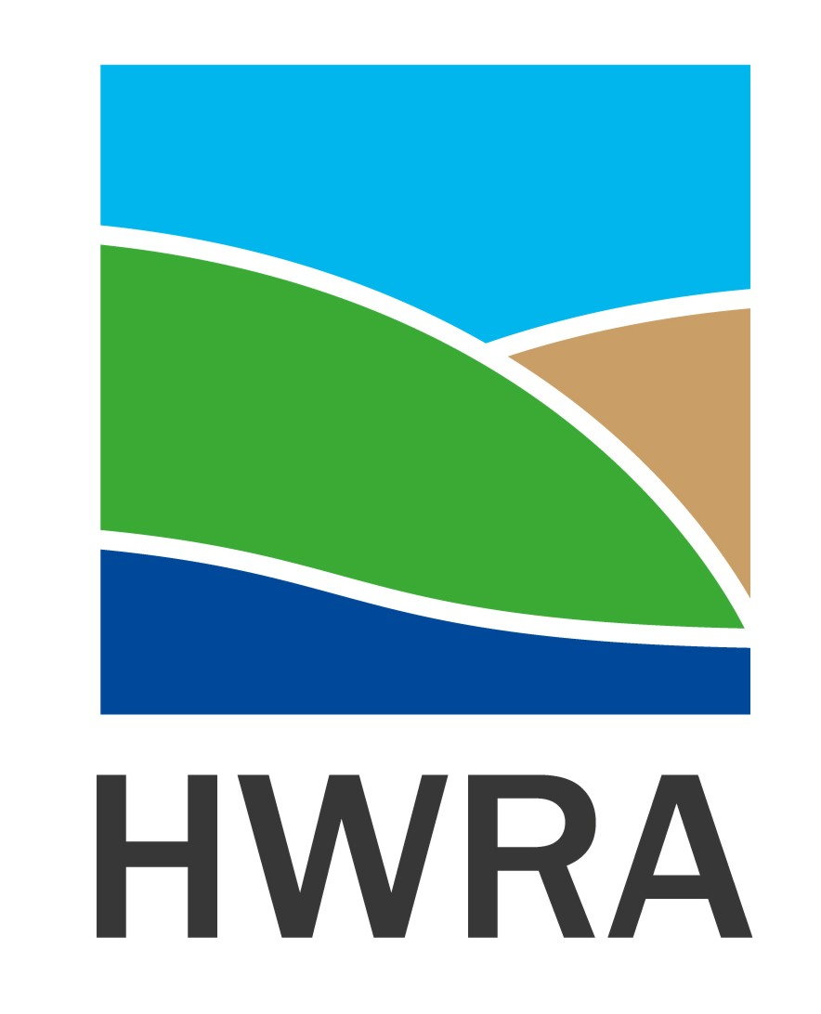
HWRA activity against the organisational Strategic Aims:
- Improve the health, security and wellbeing of communities
  - Continued support, facilitation and development of individual Men in Sheds in East Riding and North Lincolnshire and through the Humber-wide Shed Alliance assisted Sheds to reach out digitally and by telephone to members to maintain contact at a time when the Sheds were closed but needed the most
  - Undertook over 600 welfare calls to customers and drivers of the North Lincolnshire Voluntary Car Service before reopening again in line with government guidelines following safety rules and wearing PPE, working in ‘bubbles’ to assist people to essential medical appointments
  - Represented the North Lincolnshire Voluntary Community and Social Enterprise Alliance at the North Lincolnshire Integrated Adults Partnership Board and as a result developed the following initiatives: Welcome Home (discharge from hospital service), Ironstone Centre Meet and Greet/Making Every Contact Count/Social Prescribing Service; Low Level Intervention Service
  - On behalf of the North Lincolnshire Voluntary Community and Social Enterprise Alliance, developed the Alliance Volunteer Hub which recruited, trained, deployed, supported and developed volunteers who undertook a range of activities including providing shopping, prescriptions collection, dog walking etc. for people who were Shielding or vulnerable
  - The North Lincolnshire Alliance Volunteer Hub also recruited 345 Vaccine Volunteers who have played an essential role in the multi-partnership roll out of Vaccine Centres across North Lincolnshire
  - Represented rural communities at the Humberside Police North Lincolnshire Independent Advisory Group (NLIAG) and Rural Safety and Crime sub group

- Support the growth of the rural economy

  - Delivery of the North East Lincolnshire Wheels to Work scheme, averaging 6 out of 10 scooters on hire. Development of an e-cycle initiative to attract people into cycling as an alternative to petrol scooters or cars, increasing health benefits and reducing carbon
  - Developing the North Lincolnshire Alliance Volunteer Hub created opportunities for people to volunteer on their journey towards employment, developed the brokerage service with voluntary, public and private sector organisations seeking and facilitated the Volunteer Managers Network to maintain and develop a quality volunteering experience for all parties
  - As a member of the East Riding Voluntary and Community Sector Network working with Hull and East Riding Timebank, Smile, East Riding Voluntary Action Service (ERVAS) and East Riding of Yorkshire Council (ERYC) developed a response to the Digital Divide agenda at 3 levels: Equipment (Hull and East Riding Timebank refurbishing and delivering laptops to individuals); Confidence building (ERVAS, ERYC and KCom developing training to help people to use digital equipment confidently and safely); Connectivity (HWRA, East Riding Village Halls Network and Hull Homelessness Outreach developing digital connectivity and sharing options to facilitate access where it does not currently exist or is poor quality).

- Strengthen and represent our partnerships

  - Active member of the East Riding Voluntary and Community Sector Network engaging and working in partnership with representatives from the community, local authority, police, fire and health commissioners and providers
  - Active member of North Lincolnshire Voluntary, Community and Social Enterprise Alliance working in partnership with North Lincolnshire Council, Clinical Commissioning group and health and social care providers
  - Representing North Lincolnshire on the Humber, Coast and Vale Health and Care Partnership Voluntary Community and Social Enterprise Leadership Group and also as VCSE representative on the Digital Workstream
  - As a member of Action with Communities in Rural England (ACRE) and the ACRE Network which represents 38 Rural Communities across England, providing rural and community evidence and intelligence on the impact of the pandemic to influence decision-making, policy and service development.

- Sustain and develop community facilities, assets and services

  - Through the invaluable relationship with ACRE, providing timely and quality information via the Village Halls Advisory Service to rural community buildings across East Riding of Yorkshire, North Lincolnshire and North East Lincolnshire during the pandemic
  - Working in partnership with East Riding Village Halls Network, develop the roles of village and community halls to become Digital Hubs to support residents, local communities, groups, organisations and businesses seeking solutions particularly where connectivity is poor or non-existent
  - Created 5 North Lincolnshire Good Neighbour Schemes and developed the Community Network which facilitates the shared learning from the local community/Mutual Aid Groups who continue to respond to the pandemic

- Assist communities to influence, plan and develop resources and assets that respond to local needs

  - Virtual delivery of Community Led Housing Workshops and support for 8 communities at various stages of developing their own Community Led Housing Scheme. In partnership with Community First Yorkshire, developed the Community Led Housing Hub providing support to communities across North Yorkshire and East Riding
  - Facilitating the Domestic Heating Oil Bulk Buying Cooperatives in the East Riding of Yorkshire (185 members) and North Lincolnshire (27 members) saving Members money on their heating oil

- Be a strong, healthy, respected and responsive organisation

  - Undertaking risk assessments and business continuity plans for staff members, projects, services and the organisation prior to closing the physical office and moving all activity on line, virtually and by telephone in line with government guidance
  - Adopting Zoom and Teams as a way to regularly keep in touch, including a weekly staff ‘meeting’ to maintain communication, relationships, support and humour!
  - Recruited new staff (Finance Officer, Community Development Coordinator) to support core and project activity, and new Trustees to lead, challenge and develop the organisation
  - Increased regular, responsive and timely e-newsletters and social media with key public health messaging as well as HWRA project and service development and activity.
This has been a difficult and challenging year, however it has also been a year of opportunity and we would like to thank the staff team, trustees, volunteers, members and partners for supporting HWRA and in so doing, you have enabled us to support the communities we serve.

