Achieving our Aim
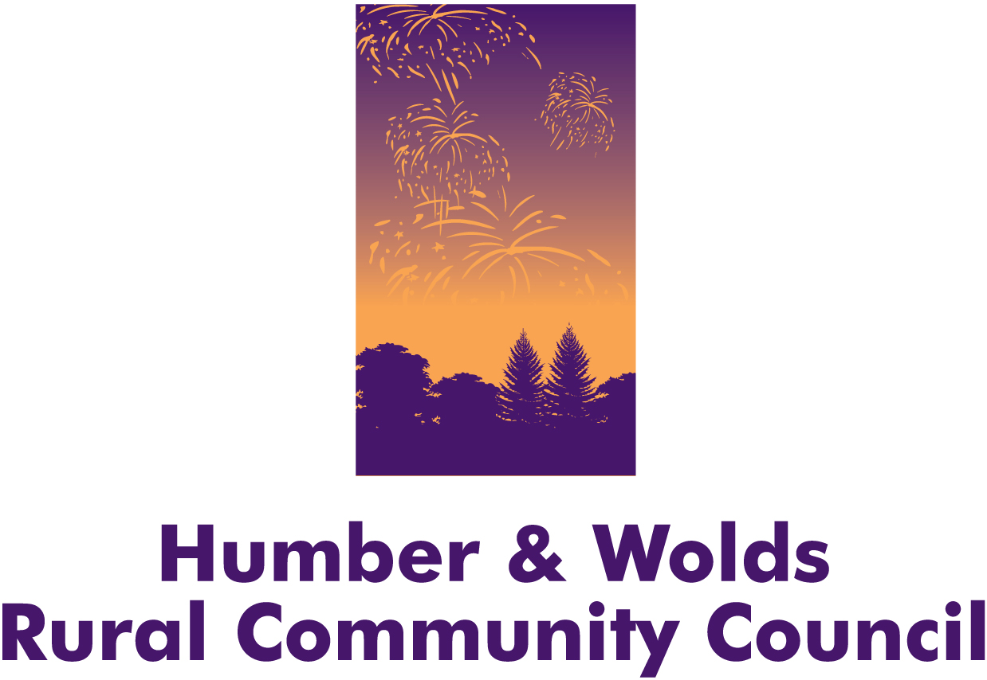
Humber and Wolds Rural Community Council (HWRCC) is an independent charity working to improve the sustainability and vibrancy of rural communities in the East Riding of Yorkshire, North and North East Lincolnshire: “Supporting Rural Communities to Thrive”.
We support and encourage rural communities to develop, so they can influence their own futures and secure a range of community facilities and services. We do this by:
- Specialising in transport and access to services, rural community facilities, rural energy, community review and neighbourhood planning
- Supporting, developing and representing rural voluntary and community organisations, social enterprises and businesses
- Creating local opportunities for individuals to contribute to and re-invest in, their community including; volunteering, community activism, training, education, ‘taster’ and employment opportunities
- Working to improve the delivery of health and social care services and services for residents particularly older people
- Gathering and analysing information on rural issues – working with communities to plan and deliver innovative, workable solutions to overcome issues and disadvantage in our rural area
- Working in partnership with other key agencies including Local Authorities, Clinical Commissioning Groups (CCG), health providers, Police, Fire and Rescue, Parish and Town Councils and other voluntary and community sector organisations
- Influencing and rural proofing local and national policy and working to strengthen the voluntary and community sector locally and nationally

HWRCC is one of 38 Rural Community Councils covering England and Wales, all operating independently and working closely with Action with Communities in Rural England (ACRE), our collective national voice which feeds directly into DEFRA.

Organisational Overview 2015-16
The 2015-16 Financial year began with an organisation reduced by 50% in order for it to continue and, hopefully build from this. Reductions included the staff team which now comprised 3.5 wte, one office at Barton, North Lincolnshire and limited unrestricted budget and reserves.
Knowledge that ACRE, the national umbrella organisation for Rural Community Councils had been able to negotiate an additional year of funding from DEFRA enabled HWRCC Trustee Board to feel confident in continuing the organisation. Having undertaken a risk management process and considered the Recovery Plan presented, revised and updated over this period, the Board gave their support to continuing with monthly financial and organisational reporting enabling them to closely monitor progress. It is through this Trustee scrutiny and support and the hard work and dedication of staff who had taken redundancy in March 2015 and those remaining with the organisation that has ensured that HWRCC has not only been able to maintain but also develop and increase project and strategic activity.

Project activities for 2015-16
Project/Activity Title | Project/activity description
Core | Action with Communities in Rural England (ACRE) the overarching body for all Rural Community Councils, to support the influencing agenda at local and national level (through DEFRA).
Village Veg | Village Veg is a Community Growing project.
Community Led Local Development (CLLD) | Communities providing their views of current and future opportunities for development to contribute towards further European Funding opportunities.
Healthy Homes | Providing practical support and solutions to people whose cold/damp homes affects their health. Healthy Homes Champions and Winter Woolly Warmers
Village SOS | Individual support plans for communities and organisations to provide advice, information, support, consultation activities, resources etc.
Wheels to Work (W2W) | To offer transport solutions to individuals who are experiencing difficulties in gaining access to employment, education or training due to lack of access to appropriate transport
Voluntary Car Service (VCS) | Delivery of Volunteer Car Services to people who live in the county. People using the service must have needs which prevent them from using public transport.
Collective Switching | Supporting the promotion of the YORswitch ‘Cheaper Energy Together’ scheme and the East Riding Oil Buying Co-operative
Community Led Planning (CLP) Pocklington | Implementation of Community Led Planning actions and development of action plans
East Riding Village Hall Membership | East Riding Village Halls joint membership with ERA of RCB (£15 pro rata)  Provision of information and support from Village Halls Advisor
Rural Energy | Provision of advice and information to individuals and organisations on energy consumption and energy saving.
Green Open Homes | Individual households opening to show local people energy saving equipment/builds including hemp and straw built houses.
EASYCare Assessment | Assessment of patient need and follow up interview as part of EASYCare pilot funded by Better Care Programme (ERYCCG/ ERYC)
East Riding YorSwitch Oil co-operative | Renewed membership of the Yorswitch Oil Co-operative scheme.
Local Links | Local events to promote voluntary organisation activity and services, update Local Links websites and forums promote volunteer activity and support in the area.
Rural Community Buildings (Miscellaneous) | AON donation from insurance taken out by village halls in the area. Used for training and village hall adviser support
Pocklington Neighbourhood Planning | Neighbourhood Planning community consultation in Pocklington and Barmby Moor.
Goole, Howdenshire and West Wolds Locality Hub Rapid Response Service | Create and implement a Rapid Response Service Pilot in the Goole, Howdenshire and West Wolds area of the East Riding. HWRCC provided voluntary and community sector representation.
Growing Greener Schools | Delivery of a growing project within schools where children learn about food origins, food miles, vegetable plot design, vegetable growing requirements, how to plant, cultivate and harvest food to be eaten.
Village Veg/Growing a Greener School | Funding to purchase resources to support the Growing a Greener School and Village Veg projects
North Lincolnshire Oil Co-operative | Creation of the North Lincolnshire Oil Cooperative including promotion and marketing, administration of the scheme, monthly auction and oil price information.
North Lincolnshire Oil Co-operative Membership | North Lincolnshire Council supported the first 100 Household’s joining the Oil Co-operative by providing free membership at £20 each.
Better Care Programme | Creation of a voluntary and community sector response to health and social care needs in the East Riding working in partnership with local commissioners and providers ‘social prescribing’.
Burstwick Community Review | Piloting of the Community Review, a ‘short and snappy’ version of Community Led Planning. Providing a range of community consultation and engagement activities
Total Transport North Lincolnshire | Voluntary sector representation on Total Transport Group, influencing ideas on alternative approaches to health and social transport.

