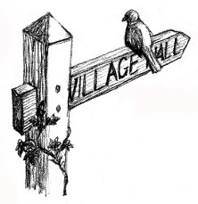

HALL TOGETHER:
At the heart of the community

A conference for village and rural community halls
Keynote Speech from the Prince’s Countryside Fund
Lectures, workshops and stalls
Thursday 12 September 2019
Holme on Spalding Moor Village Hall, YO43 4EN
Lunch and refreshments included
Closing date: Friday 23 August 2019
Contact for further information and booking form: sanctonhall@gmail.com or comms.eraofrcb@gmail.com

