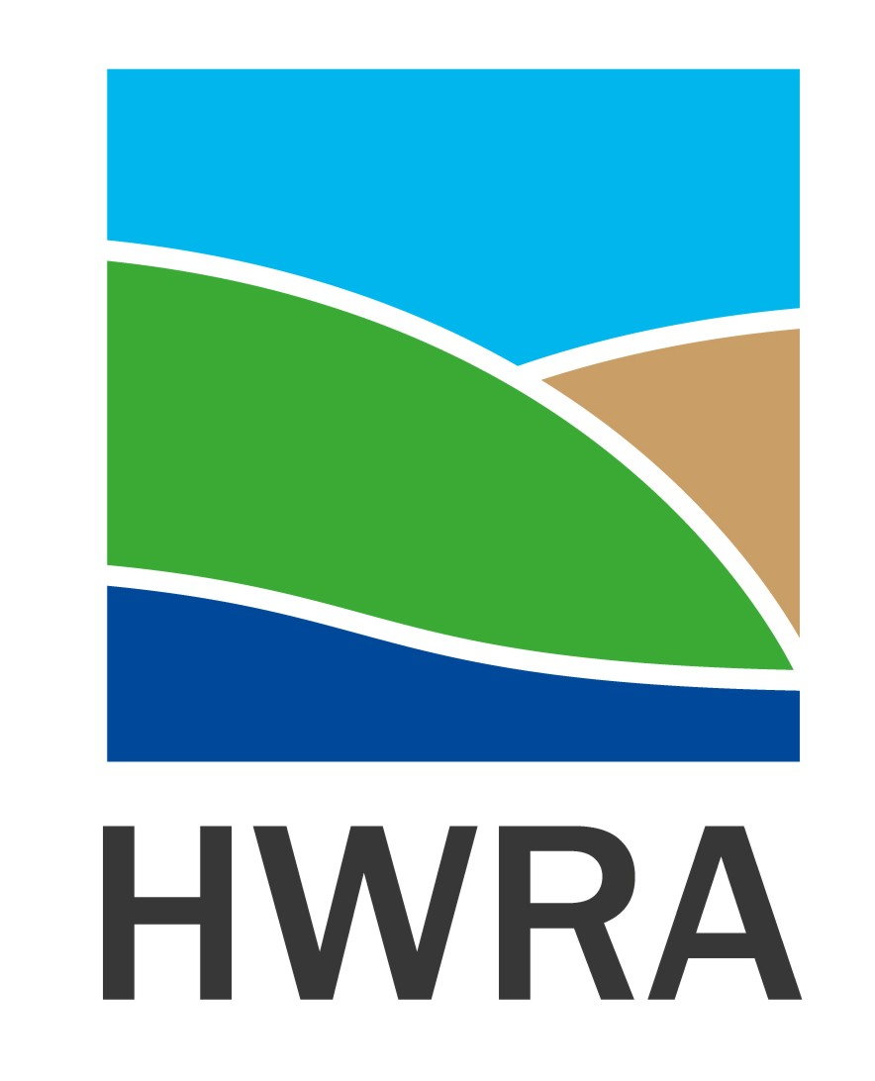

Community Development Coordinator – Good Neighbours
Funded by National Lottery Community Fund (Emerging Futures)
22.5 hours per week for a 6 month period

Humber and Wolds Rural Action (HWRA) has received funding from The National Lottery Community Fund (Emerging Futures) to build on and amplify the creativity and compassion seen in communities and across civil society during the COVID-19 pandemic. The Emerging Futures Fund is a key part of The National Lottery Community Fund’s commitment to enabling civil society to be fit for the future – supporting organisations and the voluntary sector to create opportunities to help local communities thrive.
The successful candidate will introduce interested communities in North Lincolnshire to ‘Good Neighbours’, a tried and tested model of harnessing and sustaining local community knowledge, experience and enthusiasm to support others within their community. They will support 5 self-identified communities to develop a Good Neighbours Scheme and facilitate a network of ‘Good Neighbours’ across North Lincolnshire (North Lincs Neighbours Network) bringing communities together to share ideas, experiences, concerns, issues and solutions whilst being provided with good practice, legislative and government guidance. Working together to respond to the next crisis, whether that is for an individual, family, community or nationally.
The Community Development Coordinator will have excellent communication skills (including via digital platforms), facilitation skills (enabling rather than leading communities), an understanding of the impact of Covid 19 and other issues and concerns facing communities and knowledge of the range of support available to organisations and communities to assist their development.
If you would like to find out more about this Good Neighbours project or receive an application pack, please contact:
Jacky Birkett, Delivery and Development Manager, HWRA
Email: jacky.birkett@hwrcc.org.uk
Tel: 07498 373 027

Closing date for applications/shortlisting: 9am, Monday 9th November 2020

Interview date: morning - Thursday, 12th November 2020 (if you have not been notified of an interview by this date you have not been shortlisted)

