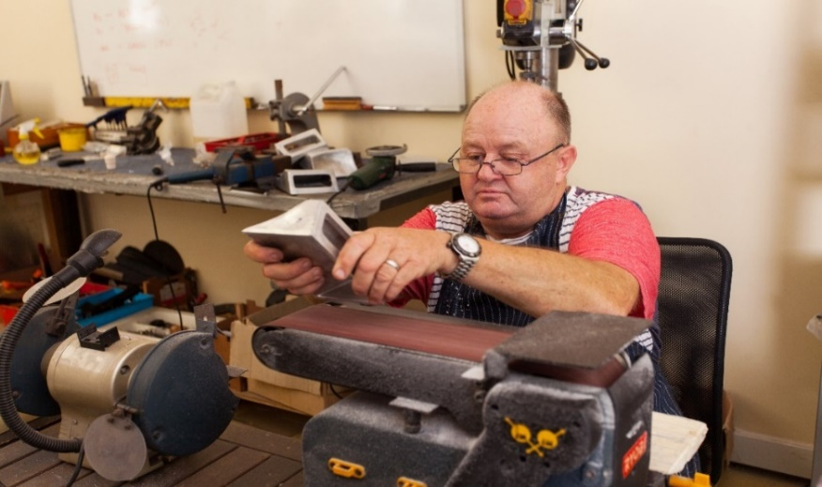
Fancy setting up a Men’s Shed in your area.
Did you know there are over 600 Sheds open in the UK?

Over 14,472 men are benefitting directly from being involved!

Why should people come?

Tell them!

Men in sheds Humberston
INFORMATION EVENTS
Date: 15 September 2021 Time: 4-5.30pm
Location: Wendover Paddock Hall, Wendover Paddock, Humberston, DN36 4HZ
Date: 17 September 2021 Time:10am-11.30
Location: New Waltham Community Hall, St Clement Way, New Waltham, DN36 4GU.
About Men’s Sheds
They are community spaces for men to connect, converse and create. The activities are often like those, of garden sheds, but for groups of men to enjoy together. They help reduce loneliness and isolation, but most importantly, they are fun!
To find out more about Men in Sheds and how you can get involved , HWRA invites you to join us at one of our information events which we are holding in your locality.
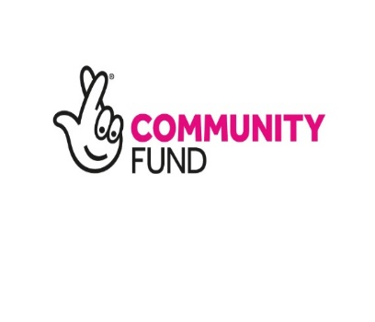
Or for further information prior to the event contact Carole Johnson carole.johnson@hwrcc.org.uk Tel: 07983479362 or to book a place contact Julie Cook Email: julie.cook@hwrcc.org.uk Tel: 01652 637700. 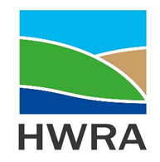
HWRA is funded by the Lottery Community Fund to facilitate the development of Men’s Sheds in Northern Lincolnshire.

