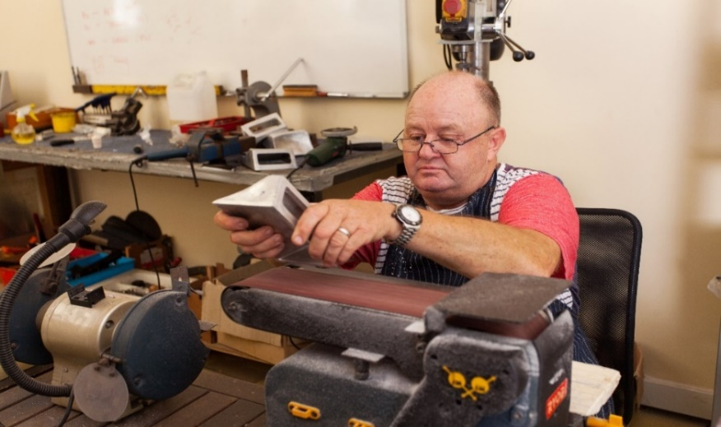

Fancy setting up a Men’s Shed in your area.

Did you know there are over 600 Sheds open in the UK?

Over 14,472 men are benefitting directly from being involved!

Why should people come?

Tell them!

**Men in sheds BRIGG**

**Brigg Market Stall Event**

**Date: Thursday 26th August 2021 Time:10am-3pm**

**Location: Market Stall at the Market Place, Brigg, DN20 8ER**

**TO FIND OUT MORE ABOUT MEN IN SHEDS AND HOW YOU CAN GET INVOLVED, HWRA INVITES YOU TO VISIT US AT OUR STALL AT THE MARKET PLACE IN BRIGG.**

**About Men’s Sheds**

They are community spaces for men to connect, converse and create.

The activities are often like those, of garden sheds, but for groups

of men to enjoy together. They help reduce loneliness and isolation, but most importantly, they are fun!

**Contact Details**

**Call and see us at our Market stall at Brigg Market on the 26 August 2021 or for further information prior to the event please contact us via email or telephone.**

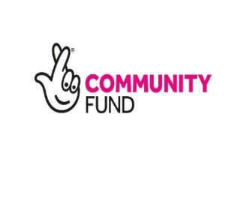**Carole Johnson** [**carole.johnson@hwrcc.org.uk**](mailto:carole.johnson@hwrcc.org.uk) **Tel: 07983479362 or**

**Julie Cook Email:** [**julie.cook@hwrcc.org.uk**](mailto:julie.cook@hwrcc.org.uk) **Tel: 01652 637700.**

