Men In Sheds News
Official opening of two Men Sheds in the East Riding of Yorkshire.
Men in Sheds Haltemprice Official Opening
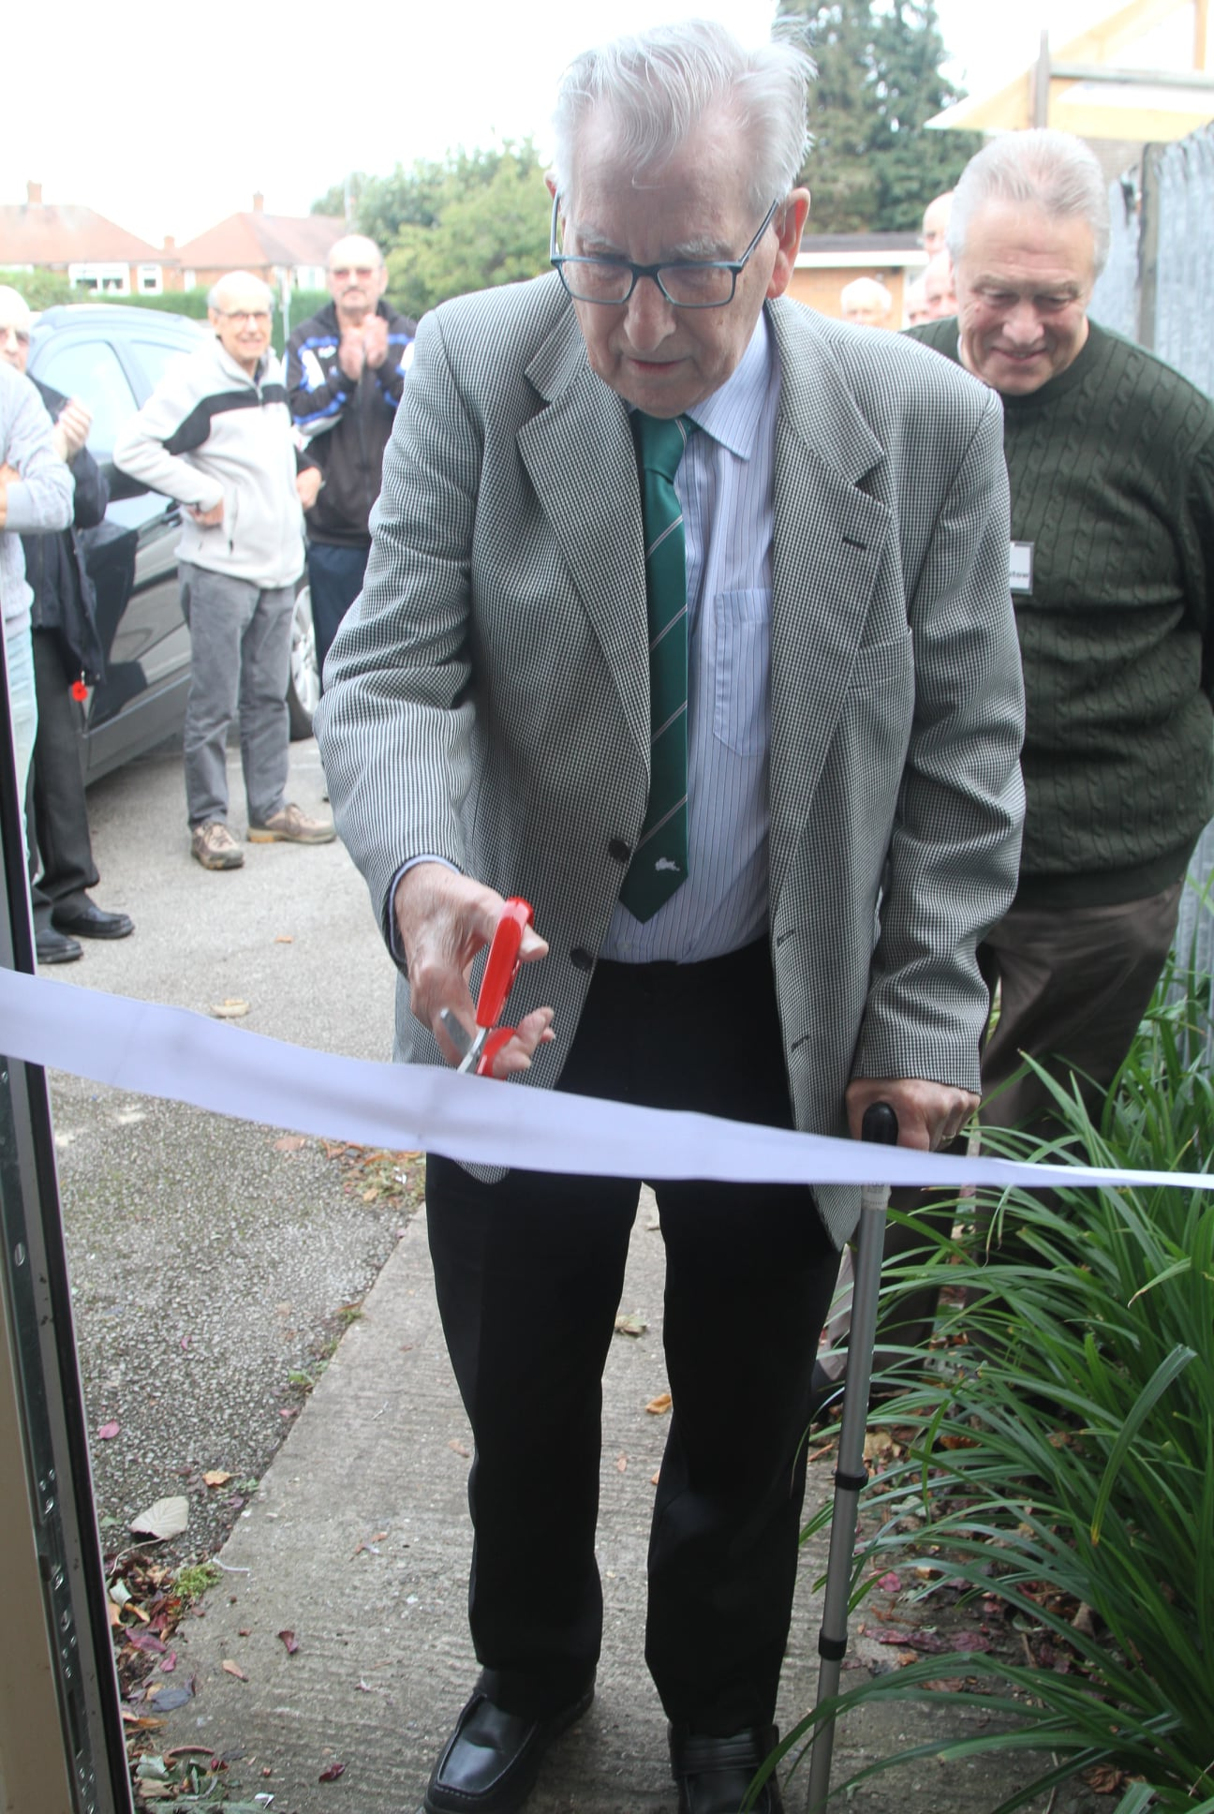
On Saturday the 2nd of October, Haltemprice shed had their official launch day of opening the shed / community building. The shed was officially opened by John Fletcher chair of the former Anlaby Community Care Association (ACCA) which previously operated from the building. ACCA have transferred ownership to Men in Sheds Haltemprice which will ensure that the building remains as a community facility for the residents of Anlaby and the surrounding area.
Attendees were invited to pop along to meet the members and see their facilities including a workshop, lounge, meeting rooms, games room and a kitchen. Despite the dull weather the launch was a success with many people coming in to find out what was on offer and how they could join. Several groups in the area are now planning on using the space including U3A for activities in their community.

Men in Sheds Driffield Official Opening
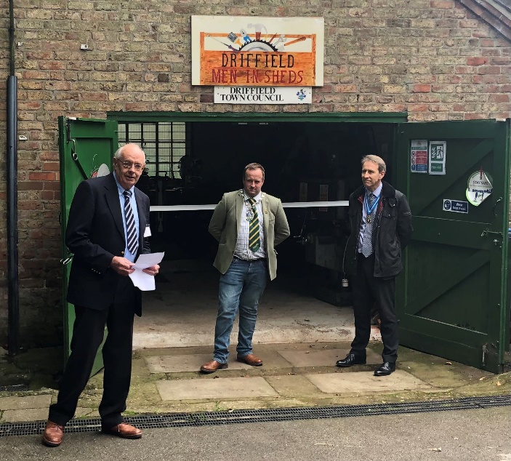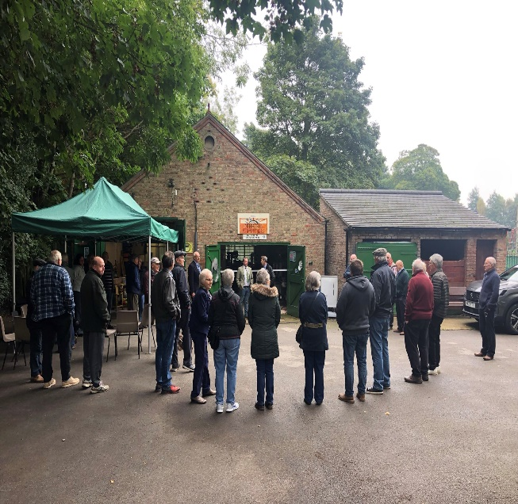
The Driffield Men’s sheds was officially opened on 18 October 21 by the High Sheriff of the East Riding of Yorkshire Richard Shepherdson and Cllr. Matt Rogers mayor of Driffield. The event was well attended by trustees, ‘shedders’ and local supporters of the shed. The opening event also attracted people who came to look around the site and its facilities for the first time.

