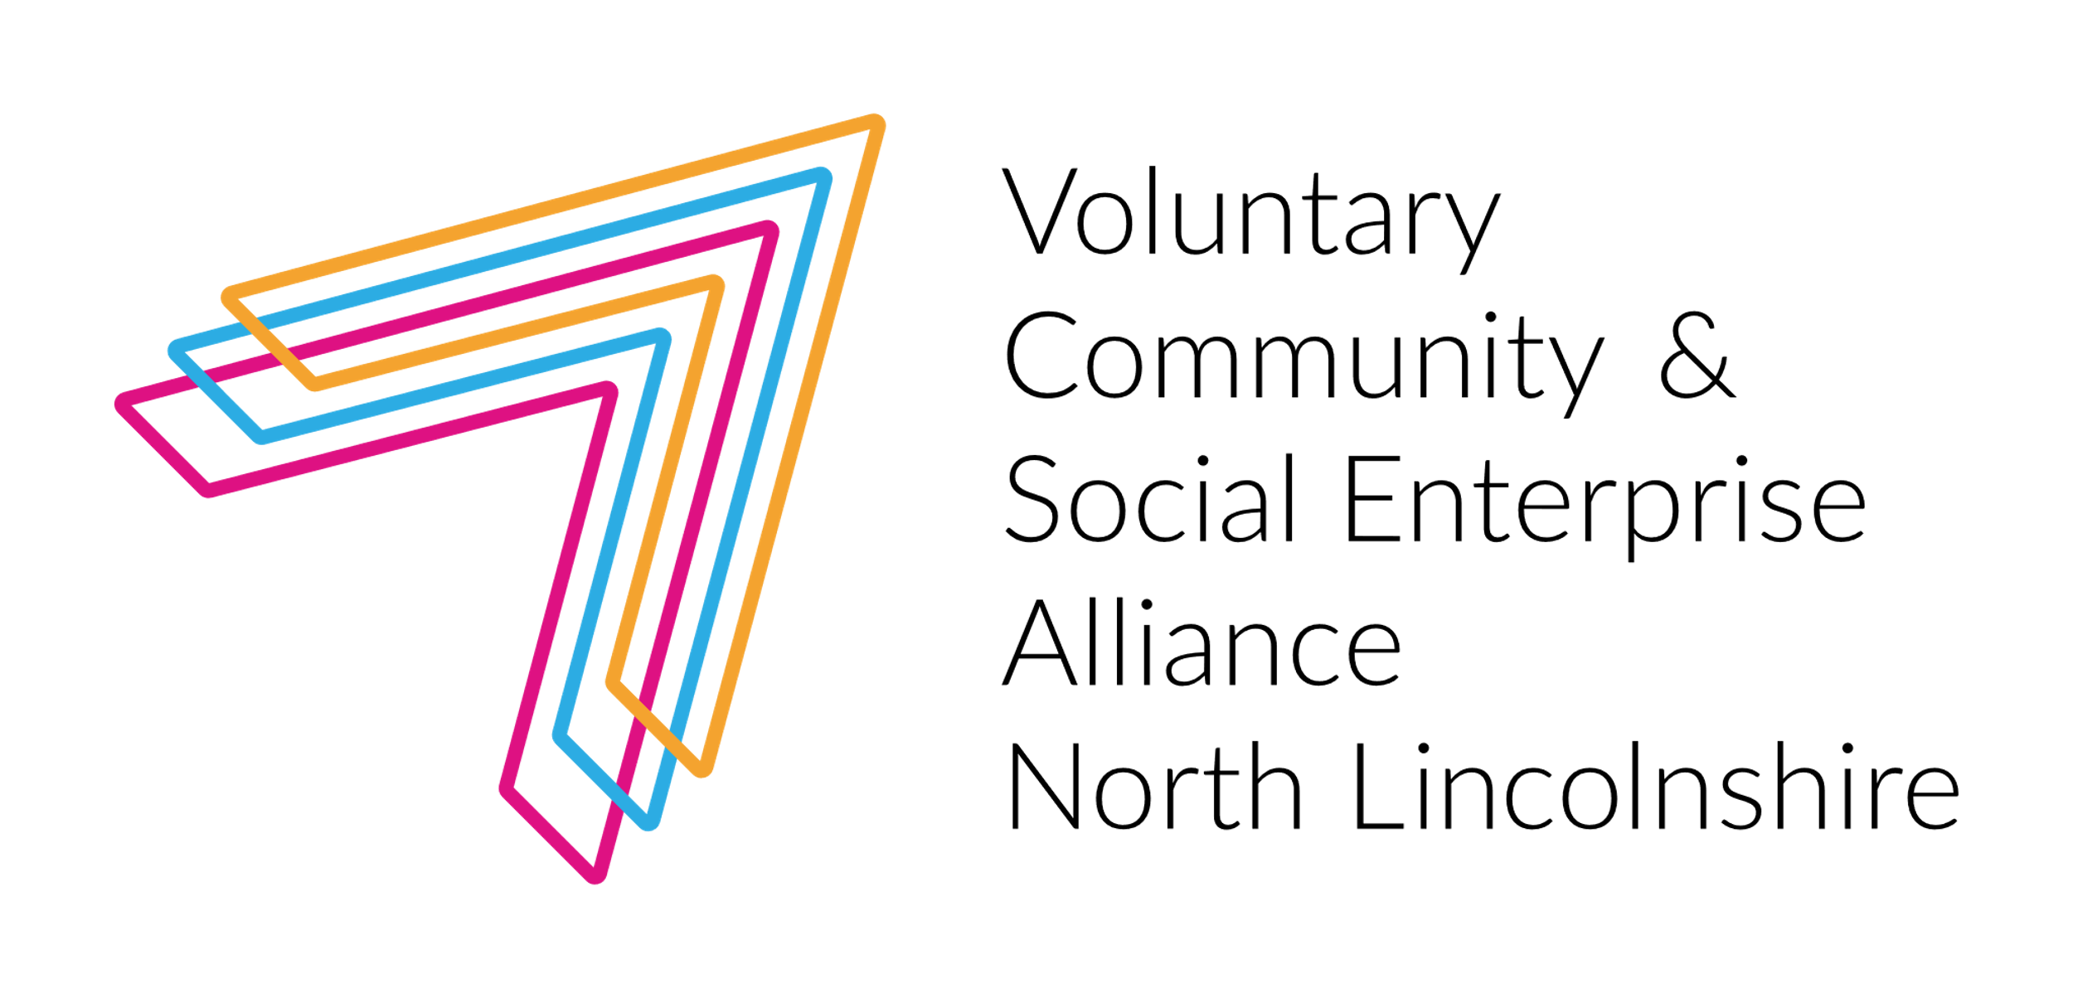
North Lincolnshire Low Level Intervention Service
Context
In the past 18 months, the role and impact of the voluntary and community sector (VCS) has come to the fore with the development of community led responses (Mutual Aid and Covid 19 Groups), an increase in volunteering (provision of shopping, prescription collection, dog walking and vaccine volunteer deployment, befriending etc.) and voluntary sector organisations adapting to meet customer needs virtually and through telephone support.
Across the system there is recognition of the role that VCS organisations and groups play but also the changing needs of residents as a result of Covid 19 on their physical and mental health and reduced access to everyday activities, previously taken for granted. We know that people have lost their confidence, contacts and support networks
We are also aware of the increased demand on health and social care but this is providing an opportunity to focus on prevention and the everyday activities that keep people happy, healthy and ‘at home’ rather than the continuous reactive response to ‘crisis’ which can occur when people feel isolated, lonely and unsupported.
Throughout 2020/21, the VCS has been asked to respond to a range of requests and it has adapted and flexed to create services and activities to support individuals and communities. This investment from the Workforce Capacity Grant, working in partnership with North Lincolnshire Council and Clinical Commissioning Group, is an opportunity to reflect on the past 18 months, consider the services that need to remain, those that need to stop, change or develop, identify the communities needs going forward and co-produce with voluntary, health and social care partners, a proactive and preventative service that responds to practical, physical and emotional needs.
The Objective
By the end of March 2022, to have developed:
- a Low Level Intervention model which will respond to ‘universal’ individual needs at a community and voluntary sector level with the associated sustainable resourcing to provide longevity
- ‘Community triage’ by co-designing and co-producing the new ‘gateway to support’ with Social Prescribing to influence the assessment of need and response and divert people appropriately to responsive flexible community responses alongside other sources of support
- volunteer, low level intervention and adult social care employment opportunities within the voluntary, public and private sectors. This will create a career structure and potential secondment and employment opportunities across system partners.
To achieve this we will utilise the following existing/temporary/developing services and activities which will be in scope to determine both customer and community need and appropriate response:
- Ironstone Centre – Meet and Greet service/Making Every Contact Count (MECC)
- Independent Living Service (NLC based within the Ironstone)
- Home First (NLC) identification of low level support needs outside the social care package
- Welcome Home (NLVCSEA) immediate support needs upon discharge from hospital
- Prevention of conveyance to acute settings (EMAS) where the call is due to loneliness or local level practical support need
- Requests for Support (NLC/NLVCSEA) people self presenting as a result of ‘Test Trace and Isolate’
- Social Prescribing (CAB/PCN’s) identification of practical, low level needs
- Befriending (Healthwatch/Age UK Lindsey) support requests including and in addition to loneliness and isolation
- Community Network (NLVCSEA) community and mutual aid groups identifying and providing for local needs
- Information, Advice and Guidance Digital Platform (and it’s forerunners) to provide access and self-service/care
- Capacity Builder identifying gaps in provision and developing sustainable long term services and activities
Although we believe we know what the low level needs are (shopping, prescription collection, cleaning, dog walking, befriending, companionship, confidence building, support to access activities etc.), until we draw together all the information gained through service provision and service gaps and that received from people within the community, we do not know what is required and in what quantities. The Low Level Intervention Service will provide capacity within the sector to research, collate and create an appropriate Place Based response.
Action plan:
The action plan:
- Employ a Low Level Intervention and Support Development Manager
- Scope out the existing services (with Social Prescribers and VCS – don’t reinvent the wheel)
- Gather data from all services identified above to determine need/demand
- Identify where existing services and activities can be replicated across North Lincolnshire and what resource is required to achieve this
- Identify where there are gaps in response and work with the voluntary, public and private sector to develop appropriate services and activities
- Seek and identify sustainable resources to develop and ‘test’ innovative responses and sustain those that need to become ‘Business as Usual’
- Develop a monitoring and evaluation tool which will measure impact on the individual, community and public services including prevention of admission to acute hospital and the resulting cost savings wherever possible
- Develop a Low Level Intervention service model which is recognised, used and resourced by all system partners as it has a proven record of preventing access to more expensive services (GP, acute hospital, ambulance, adult social care package etc.)
Low Level Intervention and Support Development Manager
Salary: £27,391 (£17.51 per hour) pro rata
Contract: 30 hours per week

Contract Period: to 31st March 2022 (start date will be determined by successful candidate but anticipate at least 6 month contract)
See full job description for details, overall role:
- Develops the service at Ironstone including the relationship with the Independent Living Centre and Diagnostic/Frailty Service
- Coordinates all the Ironstone Atrium activity
- Acts as the named coordinator required by Ironstone/NHS Property Services
- Collates all the demand and response information to determine low level needs and how they have been met across North Lincolnshire
- Where needs are unmet as no service/response is available work with the capacity builder and NLVCSEA to determine a possible response
- Overall development and coordination of the Low Level Intervention and Voluntary Sector Support, including those within the Ironstone Centre, in line with Place, Humber Coast and Vale ICS and national initiatives
- Development of a monitoring and evaluation tool which provides qualitative and quantitative measurement and impact.
Employment:
The Low Level Intervention and Support Development Service is developed and ran by the North Lincolnshire Voluntary Community and Social Enterprise (VCSE) Alliance whose members include: Active Humber, Age UK Lindsey, Alzheimers Society, Building Resilience in Communities (BRIC), Carers Support Service, Citizens Advice North Lincolnshire/Social Prescribing, Crosby Community Association, The Forge (Homelessness Charity), Healthwatch North Lincolnshire, Humber and Wolds Rural Action (HWRA), Lindsey Lodge Hospice, North Lincolnshire Mind, Stroke Association, Voluntary Action North Lincolnshire, Westcliffe Community Works.
The lead organisation for this project is Humber and Wolds Rural Action (HWRA), therefore the successful candidate will be employed by HWRA whilst working for the Alliance.

Deadline for applications: 5pm Friday 20th August 2021
Interviews will take place: w/c 23rd August 2021 If you have not heard anything by Friday 27th August you have not been shortlisted.

Please note, secondments will be considered due to short contract period

For further information, please contact: susan.oliver@hwrcc.org.uk

