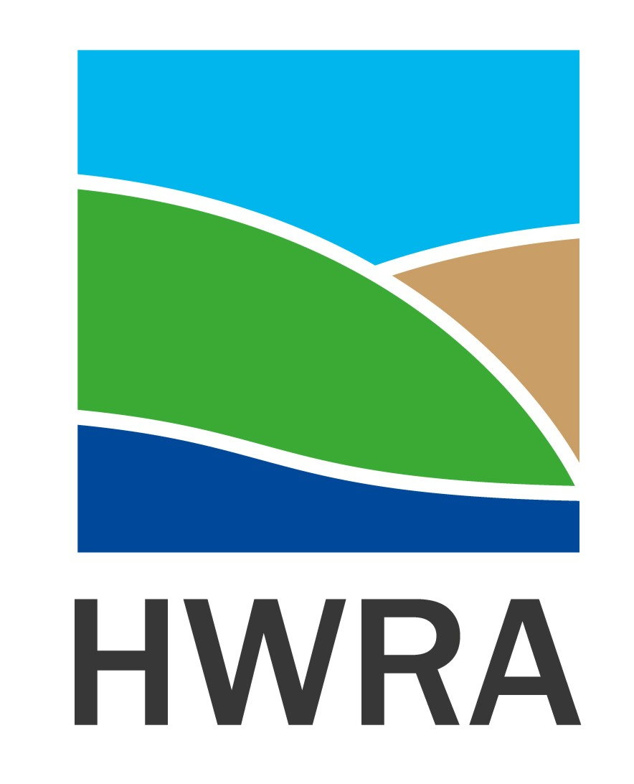

Tuesday 6th October, 2020

Humber and Wolds Rural Action receives £23,231 in National Lottery funding to support communities re-imagine a future against a backdrop of COVID-19

Humber and Wolds Rural Action (HWRA) has received £23,231 in funding from The National Lottery Community Fund to build on and amplify the creativity and compassion seen in communities and across civil society during the COVID-19 pandemic.
The funding, made possible thanks to National Lottery players, will enable HWRA to work with local voluntary and community organisations and listen and share different experiences, narrate and tell their stories and to imagine, together, what is possible in the future. The partnership will use ‘enquiries’ to invite new thinking and imagination, and support a place to experiment with community and people-led ideas.
HWRA will introduce interested communities in North Lincolnshire to ‘Good Neighbours’, a tried and tested model of harnessing and sustaining local community knowledge, experience and enthusiasm to support others within their community. We will support 5 self-identified communities to develop a Good Neighbours Scheme and facilitate a network of ‘Good Neighbours’ across North Lincolnshire (North Lincs Neighbours Network) bringing communities together to share ideas, experiences, concerns, issues and solutions whilst being provided with good practice, legislative and government guidance. Working together to respond to the next crisis, whether that is for an individual, family, community or nationally.
David Hughes, Chair, Humber and Wolds Rural Action says: “We are so pleased to have been selected to undertake this project and develop Good Neighbour Schemes within North Lincolnshire. HWRA has been developing this programme of support for some time and it is wonderful that it can now come to fruition due to the support of the National Lottery players. We thank you all very much and look forward to showing you the impact that the Good Neighbours Schemes have had on people and their communities”.
HWRA is one of 51 organisations across the UK to receive a grant of up to £50,000 through the Emerging Futures Fund. The funding, from the largest funder of community activity in the UK, will help harness the creativity of civil society and amplify the voices of communities through stories, narratives and public imagination projects.
Cassie Robinson, Senior Head of UK Funding at The National Lottery Community Fund, said: “The COVID-19 pandemic has presented new challenges to communities across the UK and The National Lottery Community Fund has focused on getting much-needed emergency support out to communities and the sector. But it has also demonstrated the very best of civil society, which has met this huge challenge with creativity, commitment and a desire for change. We are now seeing new ways of doing things that we might not have thought of before.
“Thanks to National Lottery players, these new grants will support communities to consider how they can face the immediate impact of COVID-19 but also look to the future. The activity conducted by these community groups and organisations will generate learning and insights, and create space and capacity in communities so that they are able to anticipate, imagine and shape the future.”
The Emerging Futures Fund is a key part of The National Lottery Community Fund’s commitment to enabling civil society to be fit for the future – supporting organisations and the voluntary sector to create opportunities to help local communities thrive.
Thanks to National Lottery players, up to £600 million has been made available to support communities throughout the UK during the Coronavirus crisis. The National Lottery is playing a critical role in supporting people, projects and communities during these challenging times. By playing The National Lottery, you are making an amazing contribution to the nationwide-response to combatting the impact of Covid-19 on local communities across the UK.
If you would like to find out more or get involved with this Good Neighbours project, please contact Susan or Jacky on 01652 637700 or info@hwrcc.org.uk
To find out more visit www.TNLCommunityFund.org.uk
-ends-

Contact:
Susan Oliver, Chief Executive, HWRA
Email: susan.oliver@hwrcc.org.uk
Tel: 07949 401 408

Jacky Birkett, Delivery and Development Manager, HWRA
Email: jacky.birkett@hwrcc.org.uk
Tel: 07498 373 027

www.hwrcc.org.uk

Notes to Editors:

About us
We are the largest funder of community activity in the UK – we’re proud to award money raised by National Lottery players to communities across England, Scotland, Wales and Northern Ireland. Since June 2004, we have made over 200,000 grants and awarded over £9 billion to projects that have benefited millions of people.

We are passionate about funding great ideas that matter to communities and make a difference to people’s lives. At the heart of everything we do is the belief that when people are in the lead, communities thrive. Thanks to the support of National Lottery players, our funding is open to everyone. We’re privileged to be able to work with the smallest of local groups right up to UK-wide charities, enabling people and communities to bring their ambitions to life.

Website │Twitter │Facebook │Instagram

