**TEN TOP TIPS - for Saving Energy & costs on your Fuel Bills**

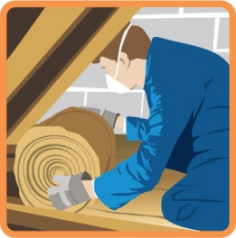**1. Insulate and draught-proof your home** – installing loft, cavity wall or other insulation will reduce your energy needs and save you money**.** Draught proofing reduces unwanted ventilation. If your home has draughty windows, doors or a letterbox then seals can be easily fitted to reduce unwanted ventilation, these can last for up to five years. However avoid blocking air vents.

**2. Check your eligibility for insulation and heating improvements** - households in receipt of certain welfare benefits may be eligible for free assistance for heating and/or insulation improvements. Consider having a benefit entitlement check as it may help with eligibility for services.



£

**3. Monitor your energy use** – Make sure you supply meter readings to your energy supplier and read your fuel bills to help you manage your energy use and spend. Take advice on whether your energy supplier is offering you the best available tariff(s) and consider fuel switching to get a better deal. Getting the right tariff is highly dependent upon your lifestyle, energy demand and preferred payment method.

**4. Seek fuel debt advice** - if you’re having difficulty paying your energy bills and are in debt to your fuel supplier then get advice. Your supplier should agree an affordable repayment plan with you. The “ability to pay” under this plan refers to what you the customer can afford not what the supplier deems affordable.

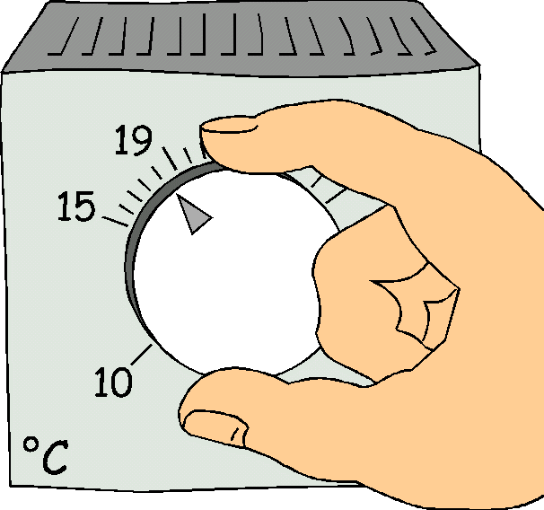**5. Register for priority services –** The *Priority Services Register* is a service provided by energy suppliers for householders who are of pensionable age, disabled or chronically sick or hearing and/or visually impaired. Services include such things as talking fuel bills, special controls and adaptors and annual gas safety checks.

**6. Control your heating** – if you have heating controls and timers then use them. Consider turning down a room thermostats by 10C to reduce internal room temperatures and save up to 10% of your energy consumption, but remember that it is always important to stay warm in your home. Ideally living rooms should be 21oC and bedrooms 18oC in colder weather.

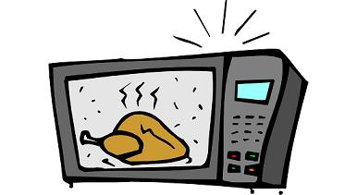**7. Control you hot water** – if you have hot water controls then use them. Avoid leaving immersion heaters on for a long time as they are expensive to use. If your hot water cylinder doesn’t have a jacket purchase one for around £10 and you can save up to £20 a year on your energy bills. Setting your cylinder thermostat to 600C will keep water warm and save energy.

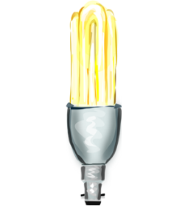**8. Use appliances efficiently** –turn off appliances when not in use and avoid using the stand-by facility as this wastes energy. Only boil what water is needed in your kettle. A microwave uses less energy than an electric oven on full power. Defrost your freezer regularly.

**9. Fit energy efficient LED bulbs** - these can last up to ten times longer than the old standard light bulb, use much less energy and could save around £50 over their lifetime whilst still supplying you with the same amount of light.

**10. Change your behaviour** – switch lights off when not in use. Keep your curtains shut at night to keep the heat in and open in the daytime to allow radiant heat in. Have a shower instead of a bath. When cooking choose the right size of pan and lid and use the correct energy settings.

**WHERE TO GET ADVICE**

**Insulation and heating improvements**

* + ECO – visit <https://www.simpleenergyadvice.org.uk/pages/energy-company-obligation>
* Main Policies: entire scheme to support low income, vulnerable and fuel poor households; requiring 15% of measures to be delivered to rural homes; supporting households that have a broken heating system by allowing the equivalent of 35,000 broken heating systems to be replaced per year; requiring the equivalent of at least 17,000 solid walled homes to be treated per year, either through solid wall insulation, or using a combination of other technologies (if equivalent savings can be achieved in the property)

**Fuel switching** (also check out Collective Switching on the internet <https://www.eastriding.gov.uk/housing/energy-efficiency/yorswitch-cheaper-energy-together/> You can also phone **01482 393939** or <https://bigcommunityswitch.co.uk/north-lincolnshire/home>

* U-Switch - Provides independent advice on fuel switching
  + [www.uswitch.com](http://www.uswitch.com) or Tel: **0800 688 8557**

**Fuel debt advice**

* Your first point of contact should be your fuel supplier
* Contact the Citizens Advice (CA) if you need additional advice
  + [www.citizensadvice.org.uk](http://www.citizensadvice.org.uk) or Tel: [**0800 144 8848**](tel:08001448848) – Adviceline (or local CAB office)

**Priority Services Register**

* Available to those of pensionable age, living with a disability or chronic illness, or with a visual or hearing impairment
* Ask your fuel supplier about their services

**Benefit entitlement checks**

* Your first point of contact should be your local authority benefits team
* Citizens Advice Bureau (CAB) may provide this service locally
  + [www.citizensadvice.org.uk](http://www.citizensadvice.org.uk)
  + Tel: [**0800 144 8848**](tel:08001448848) - Adviceline (or your nearest local CAB office)

**Energy efficiency advice**

* Energy Saving Trust (EST) – provides free impartial advice to all households
  + [www.est.org.uk](http://www.est.org.uk) & https://www.simpleenergyadvice.org.uk/
  + **0800 444 202** (Home energy efficiency advice)
  + For further energy advice visit the NEA website **–** [**www.nea.org.uk**](http://www.nea.org.uk)

**Energy saving advice is available locally through Humber & Wolds Rural Action.** **Please contact Peter Hirschfeld, the Rural Energy Advice Officer on 07539 477046 or visit the website at www.hwrcc.org.uk**

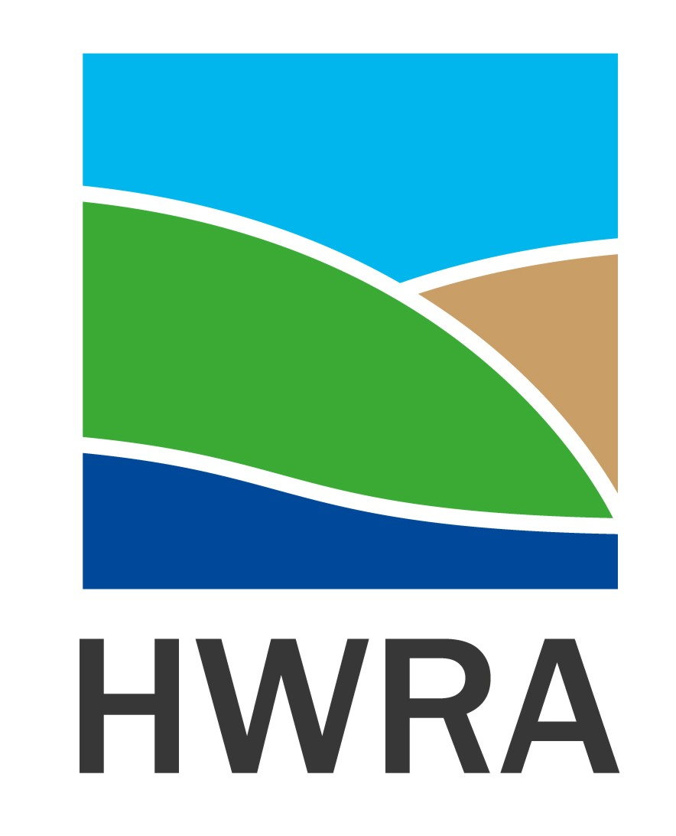

Humber & Wolds

Rural Action