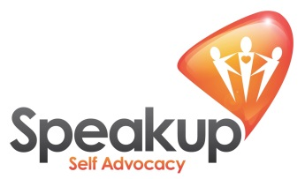

Webinar – “Coping with Covid: Supporting People with Learning Disabilities and/or Autism”, Thursday 4th March, 3:00-4:00pm
 | Coronavirus is still making a lot of people ill.
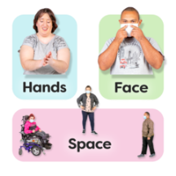 | It is important that we follow the rules to stop the virus spreading.
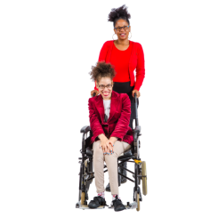 | It can be harder to follow the rules when you are caring for someone.
 | A webinar has been set up to help carers to follow the rules. It is on 4 March 2021 and starts at 3.00pm. It will last 45 minutes.
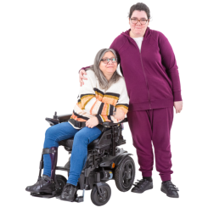 | The webinar is for anyone who is a carer or support worker. This includes family carers.
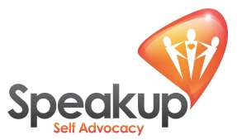 | Self-Advocates from Speak Up will explain how it feels to them to follow the rules and how staff can help with this.
 | Workers from Northern Healthcare will share how they support people to follow the rules and keep their staff safe too.
 | There will be an opportunity to ask questions to a panel of experts during the webinar.
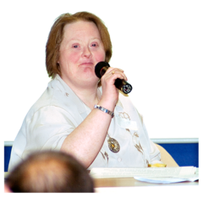 | Marin Farran, Director of Adult Social Care from Liverpool will chair the webinar.
 | You can sign up for the webinar here: Covid: Supporting People with Learning Disabilities and/or Autism Tickets, Thu 4 Mar 2021 at 15:00 | Eventbrite
