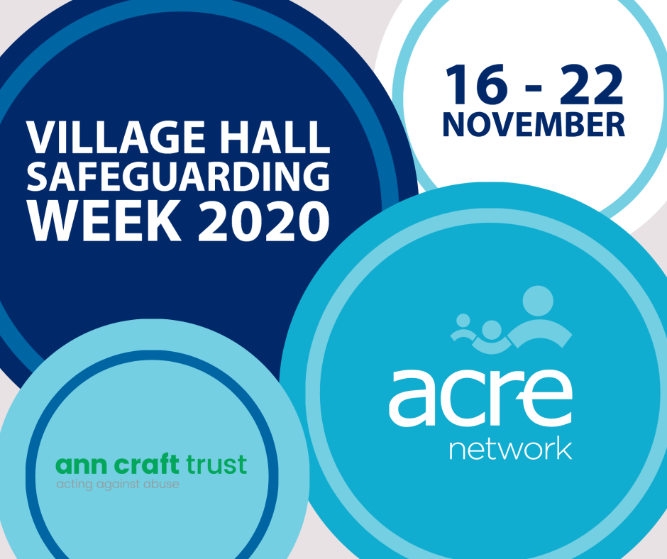

Action with Communities in Rural England (ACRE) has been awarded over £100K from the National Lottery Community Fund to promote good safeguarding practice to village and community halls throughout England

The aim of this project is to ensure that every village and community hall across rural England have the knowledge and confidence to provide a safe environment for all. It aspires to improve the awareness of safeguarding, extend the reach of resources, provide an insight into the impact and embed good practice.

To find out more, please contact Carole Foster, Village Halls Advisor on 01652 637700 or email villagehallsadvisor@hwrcc.org.uk

For more information about the safeguarding requirements for your hall, follow the links below:

NVCO Safeguarding information
http://knowhow.ncvo.org.uk/safeguarding
NSPCC child protection guidance
http://learning.nspcc.org.uk/safeguarding-child-protection/voluntary-community-groups/
Safeguarding concerns: practice example – hiring out space
http://learning.nspcc.org.uk/safeguarding-child-protection/safeguarding-concerns-practice-examples/
Safeguarding guidance for disabled children and adults at risk
http://www.anncrafttrust.org/resources/

