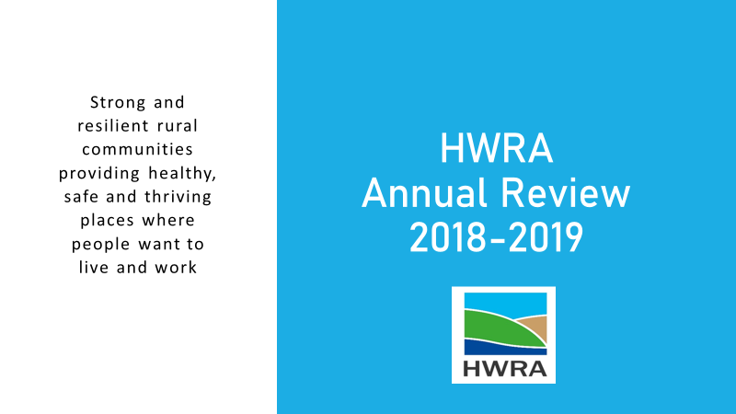

**Humber and Wolds Rural Action**



**Progress against Strategic Aims**

At the HWRA AGM in 2018, the new draft Forward Strategy 2018 to 2021 was presented to Members and Stakeholders and, as a result of this engagement, the Forward Strategy was revised, agreed and used as a guide for the Trustee Board and staff team to continuously develop the organisation.

The Trustees have also paid due regard to the HWRCC Memorandum and Articles, relevant legislation and guidance issued by the Charity Commission in the delivery of its Strategic Aims and related activities.

1. **Improve the health, security and wellbeing of communities**
   1. East Riding Men in Sheds continued to support the development of Withernsea Men in Sheds whilst facilitating four further Sheds in Western Wolds (Holme Upon Spalding Moor), Goole, Beverley and Hornsea
   2. Represented East Riding Voluntary and Community Sector (VCS) on the Better Care Programme Board, promoting the role of the sector in supporting local people and communities in the prevention of and reaction to, increased health and social care needs
   3. Meeting with the new East Riding Adult Social Care Director facilitating his understanding of the current VCS offer and the willingness and ability to enhance, change or adapt to meet future needs and gaps
   4. North Lincolnshire Voluntary Car Service assisted people to health and social care appointments, undertake essential shopping and reduce loneliness by connecting people to communities, friends and families. 7830 journeys were undertaking driven by 37 Volunteer Car Drivers.
   5. In partnership with Age UK Lindsey, worked with two national providers on their submission to deliver the North Lincolnshire Non-Emergency Patient Transport Service (NEPTS), supporting the successful provider, Savoy Ventures
   6. Represented the North Lincolnshire Voluntary and Community Sector Alliance at the Out of Hospital Transformation Board. Enabling system leaders (acute hospital provider, community health provider, mental health provider, CCG, Local authority adult and community services) to understand the role of community based assets.
   7. Invited Humberside Police and Crime Commissioner (PCC) to meet with the Trustee Board to explain the work of HWRA, raise the concerns faced by communities in relation to rural crime and how the VCS is able to assist in meeting the PCC priorities
   8. Representation of rural communities at the North Lincolnshire Independent Advisory Group (NLIAG)
2. **Support the growth of the rural economy**
   1. Delivery of the North East Lincolnshire Wheels to Work scheme, averaging 6 out of 10 scooters on hire. Undertook a feasibility study to consider relocation of the storage and allocation facilities into the area of benefit.
   2. Delivery of Action Towards Inclusion (ATI), Building Better Opportunities programme funded by Big Lottery Community Fund and European Social Fund and led by Your Consortium in the East Riding. Acting as Keyworker and Intervention partner, breaking down barriers for people furthest from employment, with the additional issue of living rurally.
   3. Working in partnership with the North Lincolnshire Voluntary and Community Sector Alliance, North Lincolnshire Council Adult Social Services and North Lincolnshire Clinical Commissioning Group (NLCCG), facilitated a networking and volunteer recruitment event in Volunteer Week.
   4. HWRA represented the voluntary and community sector on the Yorkshire Coast, Wolds & Waterways LEADER programme on the Local Action Group and Decision Making Board. Including consideration, approval and support for farm diversification, improving farm productivity, rural tourism, local services (including village halls and transport) and cultural and heritage projects.
3. **Strengthen and represent our partnerships**
   1. Facilitate development of the East Riding Voluntary and Community Sector Network providing an opportunity for the sector to engage with representatives from the community, local authority, police, fire and health commissioners and providers
   2. Attended the East Riding Health and Social Care Showcase System Leader’s event to hear the progress made to date, influence direction and identify future opportunities for voluntary and community sector development
   3. Represent rural communities and voluntary sector organisations at the Humberside Police and Crime Commissioner ‘Engage East Riding’ group alongside other community representatives, public sector commissioners and providers
   4. Attend the East Riding Rural Partnership to continue to challenge the inequality in delivery across rural areas and celebrate the innovative and resilient communities that we represent
   5. With VCS partners, facilitated the development and formalisation of the voluntary sector led North Lincolnshire Voluntary and Community Sector (VCS) Alliance which including creating opportunities to represent the sector and engage with lead officers from North Lincolnshire local authority and North Lincolnshire Clinical Commissioning Group
   6. Presented to the North East Lincolnshire Public Services Monitoring and Development Board (PSMDB) to promote the range of services provided by HWRA
   7. Attend the Voluntary Action North East Lincolnshire (VANEL) led North East Lincolnshire Volunteer Managers Forum to raise issues in relation to rural delivery, promote HWRA services and work with partners to continuously improve the quality and support of volunteers and volunteer managers across the county
   8. Represented Humber, Coast and Vale Health and Care Partnership at local and national events, promoting the role of communities and the voluntary sector in sustaining people’s health and wellbeing through activities, assets and people
   9. With Action with Communities in Rural England (ACRE) and the ACRE Network which represents 38 Rural Communities across England, provide evidence and information to central government departments
4. **Sustain and develop community facilities, assets and services**
   1. Deliver the Village Halls Advisor Service to rural community buildings across East Riding of Yorkshire, North Lincolnshire and North East Lincolnshire
   2. Work in partnership with East Riding Association of Rural Community Buildings (ERA of RCB) to develop Village Hall Management Committees including assessing the national Hallmark Quality Standard for village halls, assisting them to sustain these valuable community assets into the future
   3. Facilitated the development of a Northern Lincolnshire Village Hall Network Forum bringing together village hall management committee members to share good practice and resources and discuss and resolve common issues
   4. Working with a merging GP Practice and two community transport providers to create a local, sustainable response to transport needs in the Willerby and Swanland area
   5. Provided advice to people seeking to make local changes and maintain local services e.g. Preston traffic management, Ryehill Village Hall ownership, Hedon Post Office temporary closure and Tickton Post Office and village shop threatened closure.
5. **Assist communities to influence, plan and develop resources and assets that respond to local needs**
   1. Stimulating community interest in East Riding of Yorkshire Community Led Housing whether geographical, common needs or common interest. 8 villages/parishes applied for and utilised Community Housing Fund monies to research housing needs
   2. Facilitating the Domestic Heating Oil Bulk Buying Cooperatives in the East Riding of Yorkshire (183 members) and North Lincolnshire (28 members) saving Members over the membership year, between approximately £112.07 for a regular 500 litres oil order (£20 household membership)
   3. Engaging parish councils and communities in Community Led Planning including Ousefleet, Swinefleet, Middleton on the Wolds, Tickton and Routh (all East Yorkshire)
6. **Be a strong, healthy, respected and responsive organisation**
   1. Maintaining a small, high quality, core staff team with a range of community development skills and specialist knowledge and experience, supplemented by Associates and temporary staff in response to community need and project and service development
   2. Invest in the organisation increasing management and administrative capacity to respond to local, regional and national needs
   3. As a member of North Lincolnshire Wellbeing at Work, encouraged staff to eat more healthily and move more including the 10,000 Step Challenge

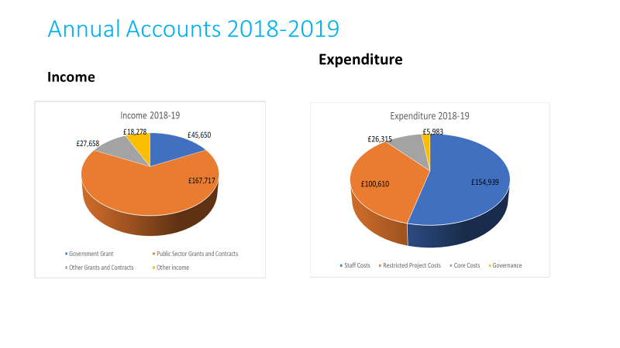

**Project Leads:**

Carole Foster:

Voluntary Car Service

Village Halls Advisor



If you would like to find out more about the projects and services provided by HWRA, have a project idea or a community or rural issue that that you would like to discuss, please contact us:

**Humber and Wolds Rural Action**

**Maltby Lane Hub**

**Maltby Lane**

**Barton-upon-Humber**

**DN18 5PY**

Tel: 01652 637700

Email: [info@hwrcc.org.uk](mailto:info@hwrcc.org.uk)

Website: [www.hwrcc.org.uk](http://www.hwrcc.org.uk)

*Charity No. 1099439 Company No. 4606085*

Maltby Lane Hub, Barton – HWRA new offices